* Linear combination of random variables

X1 , X2, . . . , Xn: random variables;

a1 , a2, . . . , an: constants

**­_________________________________________**is a linear combination of X1, X2, …, Xn.

* If X1, X2, … , Xn are random variables with means $μ_{1},μ_{2},…,μ_{n}$ and variances $σ_{1},σ_{2},{…,σ}_{n}$ respectively, and Y= a1X1 + a2X2 + … + anXnthen

$μ_{Y}=$
* ­____________________________________________

This result is true regardless of whether the Xi’s are ­­­­­_________________________.

* When X1, X2, … , Xn are independent random variables,

$$σ_{Y}^{2}= __________________________________________$$

This result is true only when the Xi’s are ____________________.

**Practice：**Consider a large ferry that can accommodate cars and buses. The toll for cars is $3, and the toll for buses is $10. Let x and y denote the number of cars and buses, respectively, carried on a single trip. Cars and buses are accommodated on different levels of the ferry, so the number of buses accommodated on any trip is independent of the number of cars on the trip. Suppose that x and y have the following probability distributions:

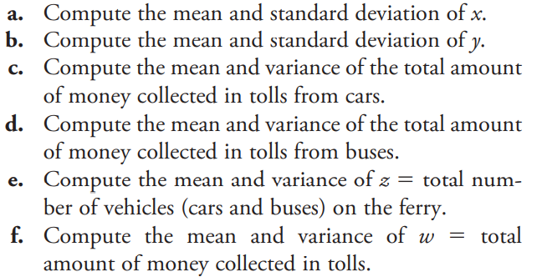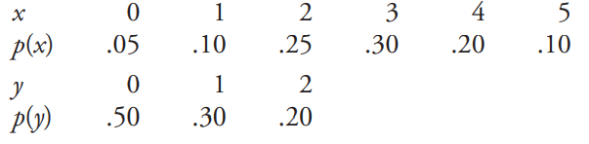

* **Bernoulli distribution**

Flipping a coin (not fair): P(H) = 0.3, P(T) = 0.7

Define a random variable Z: Z= 0 if heads, 1 if tails. What is the probability distribution of Z?

* **Binomial Setting**

A binomial setting arises when we perform ____________________________ of the and­ _______________________________________________________________________________________ .

* _______________? The possible outcomes of each trial can be classified as “success” or “failure”
* ___________________? Trials must be ­____________________.
* Number? The number of trials **n** of the chance process must be _____________________.
* Same probability? There is the **same** probability of success **p** ____________________.

**Practice:**

Define a Random Variable Y:

Y = the number of kings after taking 2 cards from standard deck without replacement

* **Does the random variable Y satisfy all Binomial Settings?**
* **Binomial Variable and Binomial Distribution**

Def. The count of successes X in a ________________________ is a binomial random variable.

The probability distribution of X is a binomial distribution.

* The possible values of X are ___________________

Any binomial distribution is completely specified by two numbers:

* + __________________________of the chance process
  + _________________________________________________
* **Probability Distribution:**

Flipping a coin (not fair): P(H) = 0.3, P(T) = 0.7.

Define a R.V.: X = the number of tails after 10 flips. What is the probability distribution of X?